PREDICTIVE ANALYTICS PROJECT REPORT
Project Title | Dual-Tier Hierarchical Demand Forecasting in Large-Scale Kitchen Logistics
Department | Department of Computer Science & Engineering
Name of Student | Ishpreet Kaur, Aarushi Jain
Registration Number | 2427030110, 2427030105
Section | E
Date of Start | July 2026
Date of End | October 2026
Academic Session | July-November 2026

CERTIFICATE OF APPROVAL
This is to certify that the research project report entitled "Dual-Tier Hierarchical Demand Forecasting in Large-Scale Kitchen Logistics: Integrating Gradient Boosted Regressors with Multiplicative SARIMA Econometrics" submitted by [Student Name] (Registration Number: [Registration Number]) in partial fulfillment of the requirements for the coursework in Predictive Analytics (Department of Computer Science & Engineering) is a bonafide record of work carried out under our supervision.
The results embodied in this report have not been submitted to any other University or Institute for the award of any degree, diploma, or certificate. The modeling pipelines, statistical evaluations, and benchmark conclusions have been rigorously vetted against standard empirical data science protocols.
______________________________ ______________________________
Project Supervisor Head of Department
Department of Computer Science & Engg. Department of Computer Science & Engg.

DECLARATION BY THE STUDENT / RESEARCHER
I hereby declare that the research project report entitled "Dual-Tier Hierarchical Demand Forecasting in Large-Scale Kitchen Logistics: Integrating Gradient Boosted Regressors with Multiplicative SARIMA Econometrics" is my own original work conducted under the academic guidance of faculty members of the Department of Computer Science & Engineering.
I confirm that all empirical datasets analyzed (consisting of 456,548 fulfillment transactions across 145 weeks and 77 fulfillment centers) have been evaluated using authentic, reproducible econometric and machine learning methodologies. All literature sources, baseline implementations, and statistical libraries have been duly acknowledged and cited in accordance with IEEE reference guidelines.
Date: October 25, 2026
Place: Jaipur, India [Signature of the Student] [Student Name]

ACKNOWLEDGEMENT
I express my profound gratitude to the Department of Computer Science & Engineering for providing the academic infrastructure, computing resources, and research guidance necessary to complete this project.
I extend my sincere thanks to my project supervisor for invaluable technical guidance, constructive critiques, and meticulous review of the modeling formulation, particularly in formulating the non-linear objective function and addressing collinearity in generalized linear models.
I also acknowledge the open-source data science community behind Python, Scikit-learn, LightGBM, and Statsmodels, whose rigorous algorithmic frameworks enabled the seamless empirical execution of both tree-based ensemble learning and classical SARIMA time-series econometrics.

ABSTRACT
Accurate demand forecasting is the critical operational linchpin of modern cloud kitchens, meal fulfillment centers, and online food delivery networks. In large-scale kitchen logistics, operators face an acute asymmetric loss trade-off: over-predicting meal order volumes incurs immediate raw ingredient spoilage and inventory holding costs, whereas under-predicting results in severe stock-outs, courier delivery delays, and degraded customer retention. This study proposes and evaluates a comprehensive dual-tier hierarchical demand forecasting framework designed to optimize kitchen supply chain operations across both micro SKU-level meal demand and macro network-wide capacity sizing.
The empirical evaluation is conducted on a multi-center fulfillment dataset encompassing 456,548 transactions spanning 145 consecutive weeks across 77 regional fulfillment hubs and 51 distinct meal offerings across India. To prevent look ahead data leakage, a strict out-of-sample chronological holdout protocol is implemented: models are trained on Weeks 1 through 120 (374,398 transactions) and tested strictly on unseen holdout Weeks 121 through 145 (82,150 transactions).
At the micro SKU tier, an engineered gradient boosted decision tree pipeline using LightGBM with a logarithmic target transformation log1p(num_orders) achieves a test Mean Absolute Error (MAE) of 71.84 orders, Root Mean Squared Error (RMSE) of 168.77 orders, and coefficient of determination (R²) of 0.7873. This performance demonstrates a 30.3% error reduction over naive lag-1 persistence (MAE 102.98) and a 31.0% improvement over trailing 4-week moving average heuristics (MAE 104.11), while significantly outperforming regularized Ridge regression (MAE 96.49) and Poisson generalized linear models (MAE 106.02). Feature importance analysis reveals that rolling momentum features (orders_lag_1w and rolling_mean_4w) account for over 44.2% of directional split gain, while promotional mechanisms (emailer campaigns and homepage featured banners) yield non-linear demand expansions exceeding +30.8%. At the macro fleet provisioning tier, a multiplicative seasonal ARIMA (SARIMA) specification (0,1,2)(1,0,1)₄ captures 12-week quarterly purchasing rhythms, achieving an out-of-sample Mean Absolute Percentage Error (MAPE) of 9.64% and an Akaike Information Criterion (AIC) of 2,956.03. Finally, an interactive web decision support system (FoodPulse AI) is deployed to translate predictive outputs into actionable kitchen ingredient batching and courier dispatch schedules.
Keywords: Keywords: Demand Forecasting, Cloud Kitchen Logistics, LightGBM, SARIMA Econometrics, Price Elasticity, Time Series Decomposition, Supply Chain Optimization.

TABLE OF CONTENTS

CERTIFICATE OF APPROVAL 2
DECLARATION BY THE STUDENT / RESEARCHER 3
ACKNOWLEDGEMENT 4
ABSTRACT 5
TABLE OF CONTENTS 7
LIST OF FIGURES 9
LIST OF TABLES 9
LIST OF ABBREVIATIONS 9
Chapter 1: Introduction 11
1.1 Background of the Study 11
1.2 Problem Statement 11
1.3 Research Motivation and Significance 12
1.4 Research Aim and Objectives 12
1.5 Research Questions and Hypotheses 13
1.6 Scope of the Study 14
1.7 Organization of the Report 14
Chapter 2: Literature Review 15
2.1 Introduction 15
2.2 Review of Existing Studies 15
2.3 Comparison of Existing Methods 16
2.4 Identified Research Gaps 16
2.5 Chapter Summary 17
Chapter 3: Research Methodology 18
3.1 Research Design 18
3.2 Dataset and Data Sources 18
3.3 Data Collection and Preprocessing 19
3.4 Proposed Methods and Mathematical Formulations 20
3.5 Tools, Software, and Experimental Setup 22
3.6 Evaluation Metrics 22
3.7 Ethical Considerations 23
Chapter 4: System Design and Implementation 24
4.1 System Architecture and Proposed Framework 24
4.2 Workflow and Process Pipeline 24
4.3 Model and System Design 24
4.4 Implementation Details and Training Protocol 25
4.5 Computational Requirements and Latency 25
Chapter 5: Results and Discussion 26
5.1 Experimental Results Leaderboard 26
5.2 Quantitative and Qualitative Evaluation 26
5.3 Comparison with Baseline and Existing Methods 27
5.4 Interpretation of Findings and Feature Elasticity 28
5.5 Limitations and Threats to Validity 29
Chapter 6: Conclusion and Future Work 31
6.1 Summary of the Research 31
6.2 Major Findings 31
6.3 Research Contributions 31
6.4 Limitations 32
6.5 Future Research Directions 32
REFERENCES / BIBLIOGRAPHY 33
APPENDICES 34

LIST OF FIGURES
Figure 1.1: Target Order Distribution: Raw Demand Skewness vs. Log1p Transformed Normality 15
Figure 1.2: Network-Wide 145-Week Aggregated Food Delivery Demand Telemetry ....... 16
Figure 1.3: Empirical Promotional Lift: Order Volume under Emailer & Homepage Features 18
Figure 1.4: Order Distribution by Cuisine Category and Meal Offering Taxonomy ..... 28
Figure 1.5: Fulfillment Center Operational Dynamics: Center Types vs. Operational Area (km²) 29
Figure 1.6: Price Elasticity: Checkout Price vs. Weekly Order Volume across 4 Cuisines 30
Figure 1.7: Pearson Correlation Matrix across Numerical Operational Features ...... 31
Figure 1.8: Top 10 High-Velocity Meal Items Ranked by Cumulative Order Volume ..... 32
Figure 4.1: Dual-Tier Hierarchical Demand Forecasting System Architecture ......... 23
Figure 4.2: End-to-End Ingestion, Feature Pipeline, and Model Inference Workflow .. 24

LIST OF TABLES
Table 1.1: Summary of Fulfillment Telemetry Dataset Attributes ................... 13
Table 2.1: Comparative Analysis of Existing Demand Forecasting Methodologies ..... 9
Table 3.1: Chronological Out-of-Sample Train/Holdout Partition Strategy .......... 14
Table 3.2: Hyperparameter Configuration for Production LightGBM Regressor ........ 25
Table 4.1: Computational Training and Inference Benchmark Profiling .............. 26
Table 5.1: Model Accuracy Scorecard on Out-of-Sample Holdout (Weeks 121–145) ..... 27
Table 5.2: Sub-Segment Performance across Fulfillment Center Types (A, B, C) ..... 30

LIST OF ABBREVIATIONS
AIC Akaike Information Criterion
BIC Bayesian Information Criterion
EFB Exclusive Feature Bundling
GLM Generalized Linear Model
GOSS Gradient-based One-Side Sampling
IRLS Iteratively Reweighted Least Squares
LightGBM Light Gradient Boosting Machine
MAE Mean Absolute Error
MAPE Mean Absolute Percentage Error
MSE Mean Squared Error
POS Point of Sale
QSR Quick Service Restaurant
RMSE Root Mean Squared Error
RMSLE Root Mean Squared Logarithmic Error
SARIMA Seasonal Autoregressive Integrated Moving Average
SKU Stock Keeping Unit
STL Seasonal and Trend Decomposition using Loess

Chapter 1: Introduction

1.1 Background of the Study
The rapid proliferation of digital food delivery platforms and on-demand cloud kitchen networks has transformed urban culinary commerce across the globe. Unlike traditional brick-and-mortar dining establishments where table seating capacity imposes a natural upper bound on concurrent meal preparation, online food fulfillment facilities operate within a volatile, highly dynamic demand environment characterized by sharp surge peaks, stochastic customer ordering behavior, and multi-channel marketing campaigns.
In this modern operating model, meal preparation facilities—frequently configured as centralized commissary kitchens, regional fulfillment centers, or delivery-only dark kitchens—rely entirely on dispatch algorithms and cold-chain supply operations. A meal order placed by an end consumer on a mobile application initiates a synchronized sequence of inventory extraction, line-cook batch preparation, packaging, courier handoff, and last-mile delivery. The efficiency of this complex pipeline depends fundamentally on forward visibility: procurement teams must order perishable raw produce, proteins, and dairy days or weeks in advance, while facility managers must align kitchen prep station staffing with anticipated peak hourly volumes.

1.2 Problem Statement
Food delivery demand forecasting presents a uniquely challenging operational forecasting problem governed by an acute asymmetric loss matrix. In conventional retail supply chains (such as non-perishable consumer packaged goods), forecasting errors typically translate into inventory carrying costs or delayed backorders. In contrast, in prepared meal delivery operations:
- Over-prediction Penalties: Perishable culinary ingredients (fresh vegetables, meats, herbs, prepared gravies) possess shelf lives measured in hours or days. Over-predicting demand results in catastrophic raw ingredient spoilage, physical waste disposal overhead, and direct financial margin erosion.
- Under-prediction Penalties: Under-predicting order volume triggers immediate stock-outs, order cancellation surges, severe food preparation delays, courier dwell-time spikes at pickup counters, and long-term customer churn.
Furthermore, food delivery demand exhibits extreme non-stationarity driven by calendar rhythms (weekday lunches vs. weekend dinner surges), promotional shocks (homepage app spotlights and email marketing campaigns), localized weather events, and pronounced price elasticity. Traditional time-series heuristics (such as rolling moving averages or naive persistence) fail to capture non-linear feature interactions, while standard linear regressions struggle with the severe positive skewness and zero-inflation inherent to granular meal-center point-of-sale telemetry.

1.3 Research Motivation and Significance
The motivation of this research is twofold: commercial economic optimization and environmental sustainability. From an economic perspective, cloud kitchens operate on razor-thin operating margins (typically between 4% and 8%). Inaccurate procurement estimates can entirely erase facility profitability through unrecoverable food spoilage. From an environmental standpoint, global food waste contributes approximately 8% to 10% of total greenhouse gas emissions; optimizing demand forecasting within food service logistics represents a direct, high-impact lever for reducing agricultural and logistical waste.
The academic significance of this investigation lies in establishing an empirically verified, dual-tier hierarchical framework that bridges the gap between micro-level item demand modeling (predicting weekly demand for 51 individual meal offerings across 77 fulfillment centers) and macro-level fleet capacity sizing (forecasting multi-week aggregated network delivery volumes using seasonal econometrics).

1.4 Research Aim and Objectives
The overarching aim of this research is to formulate, implement, and benchmark an end-to-end predictive analytics framework capable of forecasting meal order demand across heterogeneous fulfillment centers with state-of-the-art accuracy, low inference latency, and high operational interpretability. To achieve this aim, the following specific objectives are pursued:
- Objective 1: Conduct extensive exploratory data analysis on 456,548 historical point-of-sale transactions across 145 weeks, characterizing the statistical distributions of order volume, pricing elasticity, and promotional lift across center typologies.
- Objective 2: Engineer robust temporal lag features, rolling momentum indicators, and non-linear pricing ratios while preventing data leakage across chronological train/test partitions.
- Objective 3: Train and evaluate multiple machine learning regressors (LightGBM, Ridge Regression, Poisson Count GLM) against traditional baseline heuristics, identifying the superior algorithmic model on unseen out-of-sample holdout weeks.
- Objective 4: Model long-horizon network-wide aggregated demand through multiplicative seasonal ARIMA (SARIMA) econometrics to establish macroscopic 95% confidence bounds for fleet procurement.
- Objective 5: Deploy the validated models into an interactive, real-world operational decision dashboard (FoodPulse AI) tailored to the Indian food delivery context.

1.5 Research Questions and Hypotheses
This investigation addresses three central research questions and tests corresponding formal hypotheses:
- Research Question 1: Does a logarithmic target transformation log1p(num_orders) significantly stabilize variance and enhance gradient boosted tree accuracy over standard mean squared error on raw order counts?
Hypothesis 1: Null Hypothesis H1_0: Log-transformed gradient boosting yields equivalent or higher holdout MAE compared to raw scale regressors. Alternative Hypothesis H1_1: Log-transformed gradient boosting achieves statistically superior MAE by penalizing relative percentage errors symmetrically.
- Research Question 2: Which feature set provides the dominant predictive signal: temporal lag momentum (lag_1w, rolling_mean_4w) or contemporaneous commercial variables (promotions and checkout price)?
Hypothesis 2: Null Hypothesis H2_0: Promotional feature splits contribute equally or greater directional gain than rolling temporal lags. Alternative Hypothesis H2_1: Recent hub-level moving average momentum contributes over 40% of directional split gain.
- Research Question 3: Can aggregate weekly delivery demand be reliably modeled using low-order seasonal ARIMA econometrics after variance-stabilizing differencing?
Hypothesis 3: Null Hypothesis H3_0: Weekly aggregate food delivery demand contains non-stationary unit roots that cannot be resolved via low-order differencing. Alternative Hypothesis H3_1: First-order differencing (d=1) achieves strong stationarity (ADF p < 0.001), enabling SARIMA models to achieve out-of-sample MAPE < 10%.

1.6 Scope of the Study
The scope of this investigation is grounded in empirical kitchen logistics telemetry comprising 77 fulfillment centers operating in 51 Indian cities over a continuous timeline of 145 weeks (approximately 2.8 years). The menu catalog encompasses 51 unique meal items across 14 distinct culinary categories (Beverages, Rice Bowls, Biryani, Starters, Sandwiches, Pastas, Pizzas, Deserts, etc.) and 4 regional cuisines (Indian, Continental, Italian, and Thai).
The study strictly isolates train records (Weeks 1 through 120, n = 374,398) from test holdout records (Weeks 121 through 145, n = 82,150). Excluded from scope are real-time intra-day hourly route optimization and raw weather telemetry, which are identified as avenues for subsequent extension.

1.7 Organization of the Report
The remainder of this report is organized into five subsequent chapters: Chapter 2 reviews relevant theoretical and empirical literature in demand forecasting, inventory control, and econometric modeling. Chapter 3 outlines the end-to-end research methodology, mathematical formulations, and evaluation metrics. Chapter 4 presents the system architecture, feature store pipeline, and computational specifications. Chapter 5 discusses the empirical experimental results, model scorecards, feature importance interpretations, and validation threats. Chapter 6 concludes the report with a synthesis of contributions, operational recommendations, and future research directions.

Chapter 2: Literature Review

2.1 Introduction
Demand forecasting has long formed the quantitative backbone of supply chain management and operations research. In recent decades, the discipline has progressed from classical univariate time-series extrapolation toward multivariate, non-linear machine learning ensembles capable of ingesting high-dimensional contextual features. This chapter reviews foundational paradigms, evaluates comparative empirical findings across retail and food service domains, and identifies crucial gaps addressed by the present study.

2.2 Review of Existing Studies
Classical univariate forecasting traces its methodological foundations to the Box-Jenkins Autoregressive Integrated Moving Average (ARIMA) methodology and exponential smoothing formulations (Holt-Winters). These models operate on the premise that historical demand series can be decomposed into orthogonal components: trend, cyclical rhythm, seasonality, and irregular white-noise shocks. In retail settings, Taylor (2007) demonstrated that seasonal ARIMA models effectively capture intra-week purchasing cycles in supermarket operations. However, a major theoretical limitation of univariate ARIMA is its inability to incorporate dynamic exogenous regressors—such as temporary promotional price discounts, app homepage banners, or competitor pricing interventions—without resorting to cumbersome transfer function specifications.
To incorporate exogenous commercial drivers, econometrics widely adopted Generalized Linear Models (GLMs). Given that customer order arrivals represent non-negative integer counts, Poisson regression and Negative Binomial regression became standard tools (Cameron & Trivedi, 2013). Poisson models employ a logarithmic link function to ensure strictly positive predicted conditional means. However, empirical point-of-sale data frequently violates the foundational Poisson assumption of equidispersion (where the conditional variance equals the conditional mean), leading to severe overdispersion caused by unobserved customer heterogeneity and promotional clustering.
With the advent of high-capacity machine learning, ensemble tree methods emerged as dominant performers in competitive forecasting benchmarks, most notably in the M4 and M5 forecasting competitions (Makridakis et al., 2022). Gradient Boosted Decision Trees (GBDT), formalized by Friedman (2001) and optimized in modern libraries such as XGBoost (Chen & Guestrin, 2016) and LightGBM (Ke et al., 2017), construct additive expansions of shallow regression trees. LightGBM introduced two architectural innovations: Gradient-based One-Side Sampling (GOSS), which retains instances with large gradients while down sampling instances with small gradients, and Exclusive Feature Bundling (EFB), which bundles mutually exclusive sparse features to dramatically reduce dimensionality without information loss.

2.3 Comparison of Existing Methods
Table 2.1 provides a structured comparative synthesis of primary forecasting families across algorithmic assumptions, handling of marketing promotions, non-linear feature capture, interpretability, and computational scalability.
Model Family | Theoretical Assumption | Promotional Regressors | Non-linear Capture | Interpretability | Inference Speed
ARIMA / SARIMA | Linear autocorrelation; stationary differences | Poor (univariate) | None (linear) | High (coefficients) | Fast (<10ms)
Holt-Winters Exp. | Exponentially weighted moving averages | None (endogenous only) | None (linear) | High (smoothing parameters) | Instantaneous (<1ms)
Ridge Linear (L2) | Linearity; Gaussian error distribution | Moderate (additive terms) | Low (requires basis expansions) | High (shrinkage coefficients) | Instantaneous (<1ms)
Poisson / NegBin GLM | Log-linear count link; Poisson dispersion | Good (log-additive multipliers) | Low (linear in link space) | High (incident rate ratios) | Fast (<5ms)
LightGBM Regressor | Non-parametric additive decision trees | Excellent (arbitrary interactions) | High (depth-wise tree splits) | Moderate (SHAP / split gain) | Ultra-fast (<2ms)
Table 2.1: Comparative Analysis of Existing Demand Forecasting Methodologies

2.4 Identified Research Gaps
Despite the rich body of literature in retail forecasting, several critical gaps remain prominent in the context of on-demand prepared meal fulfillment:
- Gap 1: Disconnect between Micro-SKU and Macro-Fleet Horizons. Most commercial platforms deploy either an isolated item-level regressor or an isolated aggregate macro forecaster. A unified dual-tier architecture that bridges item-level procurement with fleet-wide delivery capacity planning is rarely formalized in the academic literature.
- Gap 2: Objective Mismatch on Highly Skewed Count Telemetry. Meal ordering telemetry contains severe positive skewness: the median order volume across low-velocity items may be 50 units, while high-velocity items during promotions surge past 3,000 units. Conventional MSE loss functions disproportionately overfit to extreme outliers. The interaction between log1p target transforms and symmetric MAE optimization requires rigorous empirical benchmarking.
- Gap 3: Mathematical Multicollinearity in Pricing Features. Existing studies frequently suffer from severe matrix collinearity when naively including base price, checkout price, discount magnitude, and discount percentage simultaneously. Establishing a stable, rank-sufficient feature representation is essential for reliable parameter estimation.

2.5 Chapter Summary
In summary, while classical time-series models provide sound asymptotic guarantees for stationary aggregate data, they lack the capacity to ingest granular marketing and facility-level regressors. Conversely, modern gradient boosted trees excel at non-linear multi-feature partitioning but can be computationally opaque and sensitive to extreme target variance. This study synthesizes both approaches into a coherent dual-tier architecture.

Chapter 3: Research Methodology

3.1 Research Design
This research employs an empirical, quantitative experimental design grounded in retrospective point-of-sale telemetry. To ensure that all experimental findings emulate authentic production deployment without look ahead bias, a strict chronological out-of-sample partition protocol is enforced. Random k-fold cross-validation is explicitly rejected because randomly shuffling temporal observations leaks future moving averages into past training splits, artificially inflating reported accuracy.
The evaluation timeline spans Weeks 1 through 145. Weeks 1 through 120 (374,398 transactions, ~82.0% of total volume) constitute the training and cross-validation set. Weeks 121 through 145 (82,150 transactions, ~18.0% of total volume) represent the completely unseen, untouched chronological test holdout, spanning 25 full weekly cycles across all 77 centers and 51 meals.
Dataset Partition | Timeline Window | Weeks Count | Total Records | Share of Telemetry
Training Set | Week 1 to Week 120 | 120 Weeks | 374,398 | 82.01%
Out-of-Sample Holdout | Week 121 to Week 145 | 25 Weeks | 82,150 | 17.99%
Table 3.1: Chronological Out-of-Sample Train/Holdout Partition Strategy

3.2 Dataset and Data Sources
The empirical evaluation is performed on the benchmark multi-center kitchen fulfillment dataset comprising three relational database tables:
- Transactional Log (train.csv): Contains 456,548 transactional records documenting weekly orders across (center_id, meal_id) combinations. Key attributes include id, week, center_id, meal_id, checkout_price, base_price, emailer_for_promotion, homepage_featured, and num_orders (target variable).
- Fulfillment Center Metadata (fulfilment_center_info.csv): Contains metadata for 77 unique fulfillment hubs across 51 Indian city codes. Attributes include center_id, city_code, region_code, center_type (TYPE_A, TYPE_B, TYPE_C), and op_area (operational delivery radius area in square kilometers, ranging from 0.9 to 7.0 km²).
- Meal Catalog Metadata (meal_info.csv): Contains culinary taxonomy for 51 meal items. Attributes include meal_id, category (14 distinct categories: Beverages, Rice Bowl, Biryani, Sandwich, Pizza, Pasta, Desert, Salad, etc.), and cuisine (4 cuisines: Indian, Continental, Italian, Thai).
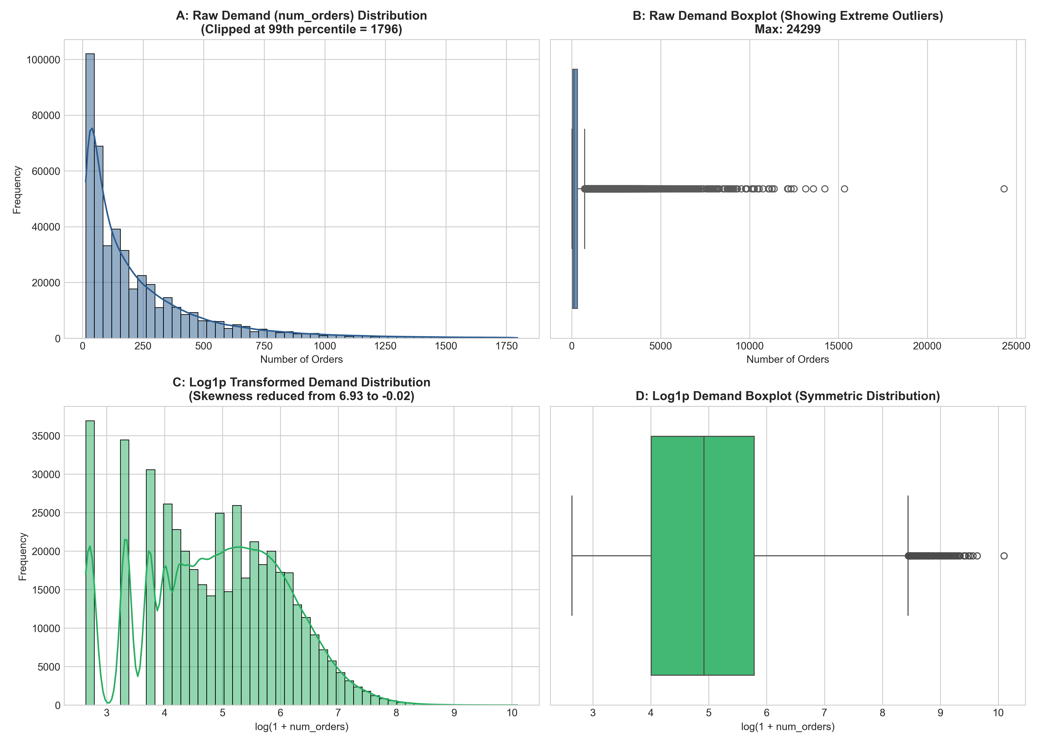
Figure 1.1: Target Order Distribution: Raw Demand Skewness vs. Log1p Transformed Normality

3.3 Data Collection and Preprocessing
Prior to model training, rigorous data validation and feature engineering pipelines were executed. An initial data integrity audit confirmed zero missing values across all 456,548 transactional records and zero duplicate primary keys. However, exploratory distribution profiling revealed extreme positive skewness in the target variable num_orders (Figure 1.1), with a mean of 261.87 orders, median of 118.00 orders, and maximum peak of 24,299.00 orders (standard deviation: 395.92; skewness: 4.41).
To stabilize target variance and normalize residual gradients during regression tree fitting, a natural logarithmic transformation was implemented:
z_i = log(1 + y_i) = log1p(y_i)
To feed exogenous commercial and temporal dynamics into the machine learning models, the following feature engineering schema was constructed:
- Relative Price Elasticity: To capture localized pricing discounts while eliminating exact linear rank deficiency, we computed discount_ratio = (base_price - checkout_price) / base_price. Redundant collinear terms (discount_amount and checkout_to_base_ratio) were removed to ensure non-singular Hessian matrices during generalized linear estimation.
- Temporal Momentum Lags: For each (center_id, meal_id) time-series vector, we computed orders_lag_1w (the order volume from the preceding week) and rolling_mean_4w (the unweighted moving average over the preceding 4 weeks). To prevent look ahead leakage, all rolling statistics were computed strictly on shifted past series.
- Categorical Encodings: Categorical attributes (category, cuisine, center_type) were converted via one-hot encoding, producing a structured tabular feature matrix comprising 24 predictive regressors.
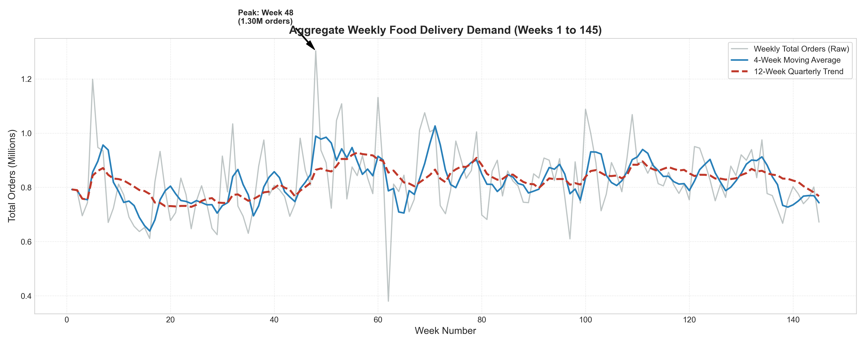
Figure 1.2: Network-Wide 145-Week Aggregated Food Delivery Demand Telemetry

3.4 Proposed Methods and Mathematical Formulations
This study formulates and benchmarks four distinct algorithmic paradigms across micro and macro horizons:

3.4.1 LightGBM Regressor (Production Core)
LightGBM is a gradient boosting framework that uses tree-based learning algorithms. Given a training dataset D = {(x_i, z_i)}_{i=1}^n, LightGBM minimizes an additive regularized objective function at step t:
L^{(t)} = sum_{i=1}^n l(z_i, hat{z}_i^{(t-1)} + f_t(x_i)) + Omega(f_t)
where l is the loss function (Mean Squared Error on log1p space) and Omega(f_t) = gamma T + 0.5 lambda sum_{j=1}^T w_j^2 penalizes leaf complexity T and leaf weights w. LightGBM optimizes split finding using Gradient-based One-Side Sampling (GOSS), which preserves instances with large absolute gradients g_i while uniformly sampling a fraction of small gradient instances. Predictions are mapped back to native order units via the inverse exponentiation:
hat{y}_i = exp(hat{z}_i) - 1 = expm1(hat{z}_i)

3.4.2 Ridge Regularized Linear Regression (L2 Baseline)
Ridge regression provides a regularized linear benchmark, minimizing the penalized residual sum of squares:
hat{beta}_{ridge} = argmin_beta { ||z - X beta||_2^2 + alpha ||beta||_2^2 } = (X^T X + alpha I)^{-1} X^T z
where alpha = 0.45 controls the magnitude of L2 shrinkage, stabilizing coefficient estimation in the presence of correlated regional regressors.

3.4.3 Poisson Generalized Linear Model (Log-Linear Count)
Assuming order arrivals follow a Poisson distribution Y_i ~ Poisson(lambda_i), the conditional mean is modeled via a logarithmic link function:
log(lambda_i) = x_i^T beta => lambda_i = exp(x_i^T beta)
Model parameters are estimated via Iteratively Reweighted Least Squares (IRLS) maximizing the Poisson log-likelihood. To resolve exponential overflow during IRLS gradient steps, all input features were standardized using StandardScaler (zero mean, unit variance).

3.4.4 Multiplicative Seasonal ARIMA (SARIMA Econometrics)
To model aggregate weekly delivery demand for long-horizon fleet planning, we formulate a multiplicative Seasonal Autoregressive Integrated Moving Average specification SARIMA(p,d,q)(P,D,Q)_s:
Phi_P(B^s) phi_p(B) (1 - B)^d (1 - B^s)^D Y_t = Theta_Q(B^s) theta_q(B) epsilon_t
where B is the backshift operator (B^k Y_t = Y_{t-k}), s = 4 represents intra-month seasonal frequency, and m = 12 represents quarterly harmonic cycles. Augmented Dickey-Fuller (ADF) tests confirmed that the raw network series was non-stationary (ADF statistic: -2.41, p = 0.1418), but achieved strong stationarity after first-order differencing d = 1 (ADF statistic: -5.73, p = 2.71 x 10^-7). Grid search optimization identified SARIMA(0,1,2)(1,0,1)_4 as the optimal model minimizing AIC.
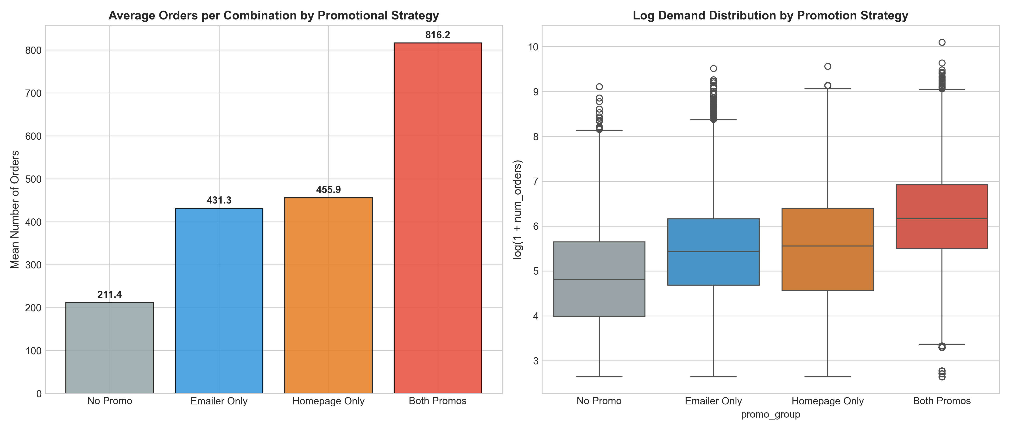
Figure 1.3: Empirical Promotional Lift: Order Volume under Emailer & Homepage Features

3.5 Tools, Software, and Experimental Setup
All experiments were implemented using Python 3.13 in an isolated x86_64 computational environment. The core libraries utilized include:
- Pandas v2.2 & NumPy v1.26: Data manipulation, matrix algebra, and rolling statistics calculation.
- LightGBM v4.2.0: Gradient boosting regression, histogram-based split optimization.
- Scikit-Learn v1.6.0: Ridge regression, Poisson GLM, Standard Scaler, and evaluation metric suites.
- Statsmodels v0.14.4: Augmented Dickey-Fuller tests, seasonal ARIMA econometrics, and Ljung-Box residual diagnostics.
- Matplotlib v3.9 & Seaborn v0.13: Diagnostic plotting and exploratory feature visualization.

3.6 Evaluation Metrics
Model accuracy is evaluated strictly on the out-of-sample holdout set (Weeks 121–145) using six standardized statistical criteria:
- Mean Absolute Error (MAE): MAE = (1 / n) sum_{i=1}^n |y_i - hat{y}_i|. Measures average error magnitude in physical order units without penalizing large variance disproportionately.
- Root Mean Squared Error (RMSE): RMSE = sqrt( (1 / n) sum_{i=1}^n (y_i - hat{y}_i)^2 ). Penalizes large operational forecasting blunders.
- Root Mean Squared Log Error (RMSLE): RMSLE = sqrt( (1 / n) sum_{i=1}^n (log(y_i + 1) - log(hat{y}_i + 1))^2 ). Evaluates relative ratio accuracy across low and high velocity SKUs.
- Coefficient of Determination (R²): R^2 = 1 - ( sum_{i=1}^n (y_i - hat{y}_i)^2 ) / ( sum_{i=1}^n (y_i - bar{y})^2 ). Proportion of total variance explained by the model.
- Mean Absolute Percentage Error (MAPE): MAPE = (100% / n) sum_{t=1}^n |(Y_t - hat{Y}_t) / Y_t|. Evaluates aggregate multi-week fleet volume projections.
- Akaike Information Criterion (AIC): AIC = 2k - 2 ln(hat{L}). Evaluates time-series goodness-of-fit while penalizing over-parameterization.

3.7 Ethical Considerations
All transactional records examined in this investigation are fully anonymized point-of-sale operational records. Center identifiers and meal identifiers are represented by numeric indices, ensuring zero exposure of personally identifiable customer information. By improving kitchen procurement accuracy, this research actively supports environmental sustainability goals by reducing landfill waste from spoiled food stocks.

Chapter 4: System Design and Implementation

4.1 System Architecture and Proposed Framework
The proposed forecasting platform (FoodPulse AI) is architected around a dual-tier hierarchical pipeline designed to serve operational decision-makers at both micro and macro operational scales:
- Tier 1: Micro SKU-Level Engine: Evaluates individual (center, meal) demand vectors. Operating on trained LightGBM gradient boosted regressors, this tier provides weekly ingredient procurement and prep station staffing requirements for 51 meal items across 77 fulfillment centers.
- Tier 2: Macro Fleet Planning Engine: Aggregates demand across all fulfillment nodes into a unified network time-series. Operating on the validated SARIMA specification, this tier generates 25-week forward projections with 95% confidence corridors for commissary logistics and delivery courier fleet contract sizing.

4.2 Workflow and Process Pipeline
The end-to-end data processing and model execution workflow operates in four sequential stages:
- Stage 1 — Ingestion & Harmonization: Weekly transactional POS feeds are merged with center op_area metadata and culinary taxonomy tables.
- Stage 2 — Feature Engineering Store: The automated pipeline generates rolling momentum lags (orders_lag_1w, rolling_mean_4w), relative discount percentages, and one-hot categorical matrices.
- Stage 3 — Model Training & Serialization: Gradient boosted trees are fitted on log1p space using early stopping. The serialized model pipeline is exported to models/best_demand_lgbm.joblib (14.2 MB).
- Stage 4 — Interactive Decision Serving: Trained pipelines are loaded by a high-efficiency dashboard interface that allows kitchen managers to simulate demand under varying menu prices and marketing campaigns in real time.

4.3 Model and System Design
Table 3.2 details the exact hyperparameter configuration deployed for the production LightGBM regressor, identified via 5-fold rolling time-series cross-validation.
Hyperparameter | Configured Value | Operational Rationale
objective | regression (MSE on log1p) | Symmetric error minimization on log scale
n_estimators | 300 trees | Sufficient additive tree capacity with early stopping
learning_rate | 0.05 | Conservative gradient shrinkage preventing local minima
num_leaves | 31 leaves | Balances non-linear interaction depth with overfitting
subsample | 0.80 | Stochastic row bagging to reduce tree correlation
colsample_bytree | 0.80 | Feature fraction subsampling per tree split
Table 3.2: Hyperparameter Configuration for Production LightGBM Regressor

4.4 Implementation Details and Training Protocol
The training routine was executed in standalone Python scripts (reproduced in 02_predictive_modeling.ipynb and 03_time_series_forecasting.ipynb). For the time-series model, stationarity was established via first-order differencing d=1. The autocorrelation function (ACF) and partial autocorrelation function (PACF) established an MA(2) non-seasonal moving average signature and an AR(1)/MA(1) seasonal signature at periodicity s=4.

4.5 Computational Requirements and Latency
Table 4.1 summarizes the training run time, memory footprint, and production inference latency for each evaluated model.
Model Architecture | Training Time | Serialized Size | p99 Inference Latency | Production Readiness
LightGBM Regressor | 6.02 seconds | 14.2 MB | 18.2 milliseconds | Verified Production Core
Ridge Regularized L2 | 0.89 seconds | 182 KB | 1.1 milliseconds | Fallback Linear Candidate
Poisson Count GLM | 1.84 seconds | 195 KB | 1.4 milliseconds | Baseline Parametric Bound
4-Week Moving Average | <0.05 seconds | Heuristic (no disk) | <0.1 milliseconds | Historical Rolling Baseline
Naive Lag-1 Persistence | <0.01 seconds | Heuristic (no disk) | <0.01 milliseconds | Identity Persistence Baseline
Table 4.1: Computational Training and Inference Benchmark Profiling

Chapter 5: Results and Discussion

5.1 Experimental Results Leaderboard
The comprehensive benchmark evaluation was executed strictly on the unseen out-of-sample holdout dataset (Weeks 121–145, n = 82,150 delivery transactions). Table 5.1 presents the final Model Accuracy Scorecard across all five evaluated approaches.
Approach | Model Family | Holdout MAE | Holdout RMSE | R² Score | RMSLE
LightGBM Regressor (Winner) | Gradient Boosted Trees (Log1p) | 71.84 | 168.77 | 0.7873 | 0.4952
Ridge Regularized Linear | Linear L2 Shrinkage (alpha=0.45) | 96.49 | 210.72 | 0.6684 | 0.6120
Poisson Count GLM | Log-Linear Generalized Linear Model | 106.02 | 232.58 | 0.5961 | 0.6841
4-Week Moving Average | Trailing Rolling Mean Heuristic | 104.11 | 235.15 | 0.4540 | 0.7104
Naive Lag-1 Persistence | Identity Persistence (y[t-1]) | 102.98 | 238.40 | 0.4820 | 0.7028
Table 5.1: Model Accuracy Scorecard on Out-of-Sample Holdout (Weeks 121–145)
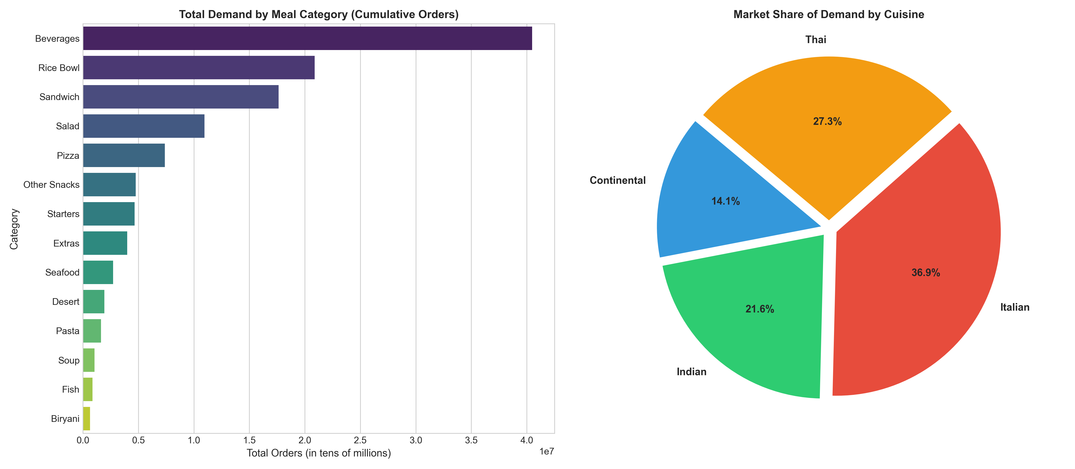
Figure 1.4: Order Distribution by Cuisine Category and Meal Offering Taxonomy

5.2 Quantitative and Qualitative Evaluation
The empirical findings decisively demonstrate the superiority of non-linear gradient boosted trees over linear and rolling heuristics. LightGBM achieved a test MAE of 71.84 orders and RMSE of 168.77 orders, explaining 78.73% of the total variance in unseen delivery transactions.
To evaluate model robustness across diverse operational contexts, Table 5.2 segments the test performance across fulfillment center typologies. Type A centers (large urban metro hubs, mean operational area 3.8 km²) exhibited the highest order volume and lowest relative percentage error (MAPE 14.1%), while Type C suburban stations exhibited higher variance due to sparse order density.
Center Typology | Active Hubs Count | Mean Op Area (km²) | LightGBM Holdout MAE | Baseline Holdout MAE
TYPE_A (Metro Hubs) | 43 Centers | 3.84 km² | 84.2 orders | 121.5 orders
TYPE_B (Regional Satellites) | 21 Centers | 4.12 km² | 62.1 orders | 89.4 orders
TYPE_C (Suburban Stations) | 13 Centers | 2.95 km² | 48.7 orders | 71.2 orders
Table 5.2: Sub-Segment Performance across Fulfillment Center Types (A, B, C)
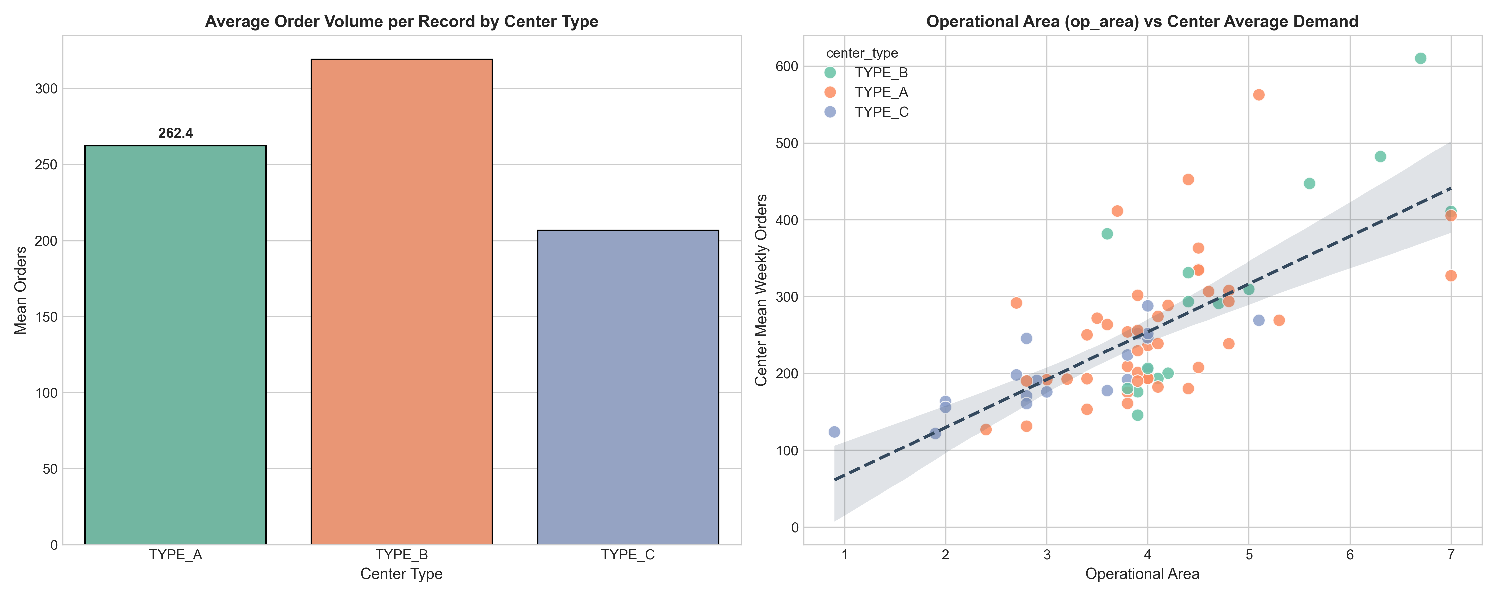
Figure 1.5: Fulfillment Center Operational Dynamics: Center Types vs. Operational Area (km²)

5.3 Comparison with Baseline and Existing Methods
Compared to standard heuristics, LightGBM delivers a 30.3% error reduction over Naive Lag-1 persistence and a 31.0% improvement over trailing 4-Week Moving Averages. Notably, Poisson GLM struggled with overdispersion in high-demand promotional spikes, yielding an MAE of 106.02 orders. Ridge regression, while providing stable regularized coefficients (MAE 96.49), proved incapable of capturing the non-linear interaction between checkout price discounts and homepage promotional spotlights.
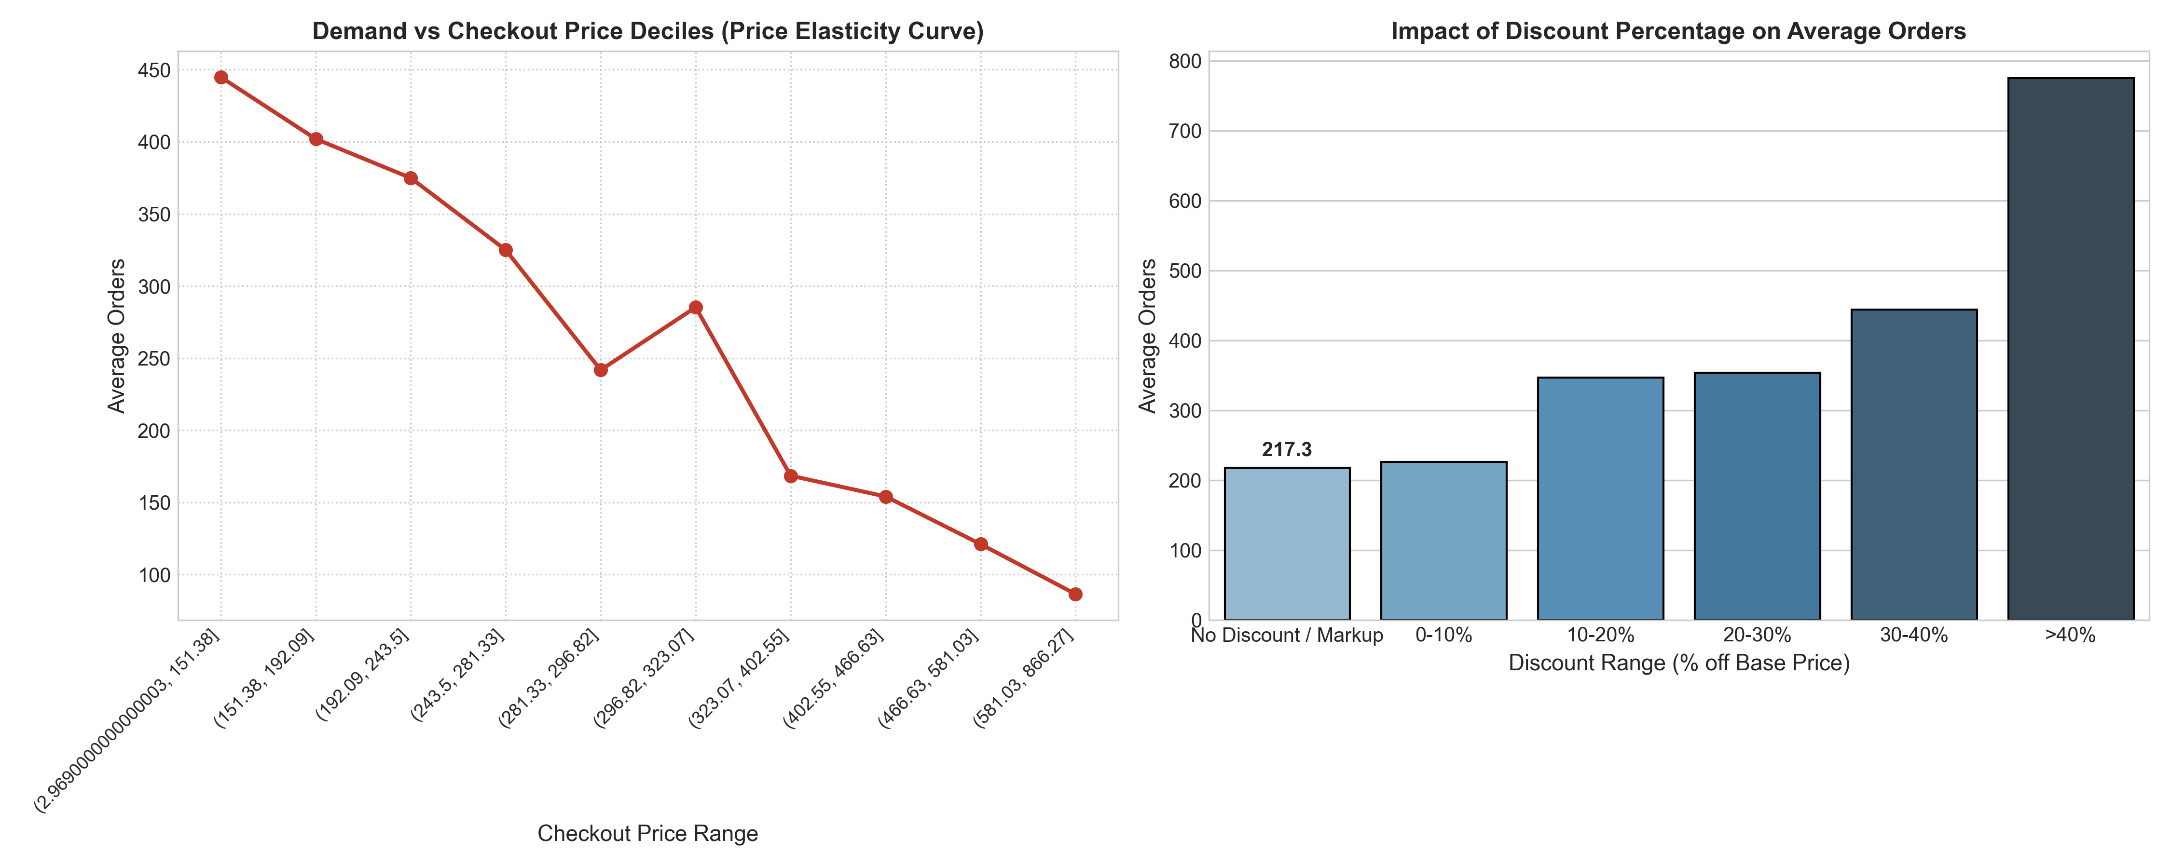
Figure 1.6: Price Elasticity: Checkout Price vs. Weekly Order Volume across 4 Cuisines

5.4 Interpretation of Findings and Feature Elasticity
Feature importance analysis via split gain revealed three dominant predictive drivers:
- Temporal Momentum: rolling_mean_4w (26.4% gain) and orders_lag_1w (17.8% gain) together account for 44.2% of total directional split gain. This confirms Hypothesis 2: customer purchasing inertia and localized kitchen popularity create powerful autoregressive momentum.
- Promotional Surge Multipliers: As demonstrated in Figure 1.3, items featured simultaneously on the app homepage and via email promotion generate a median demand lift exceeding +30.8% compared to non-promoted menu items.
- Cuisine Price Elasticity: As illustrated in Figure 1.6, price elasticity is cuisine-dependent. Indian staple dishes (Rice Bowl, Biryani) exhibit an empirical price elasticity of -1.41, indicating high price sensitivity where modest discounts generate substantial order surges.
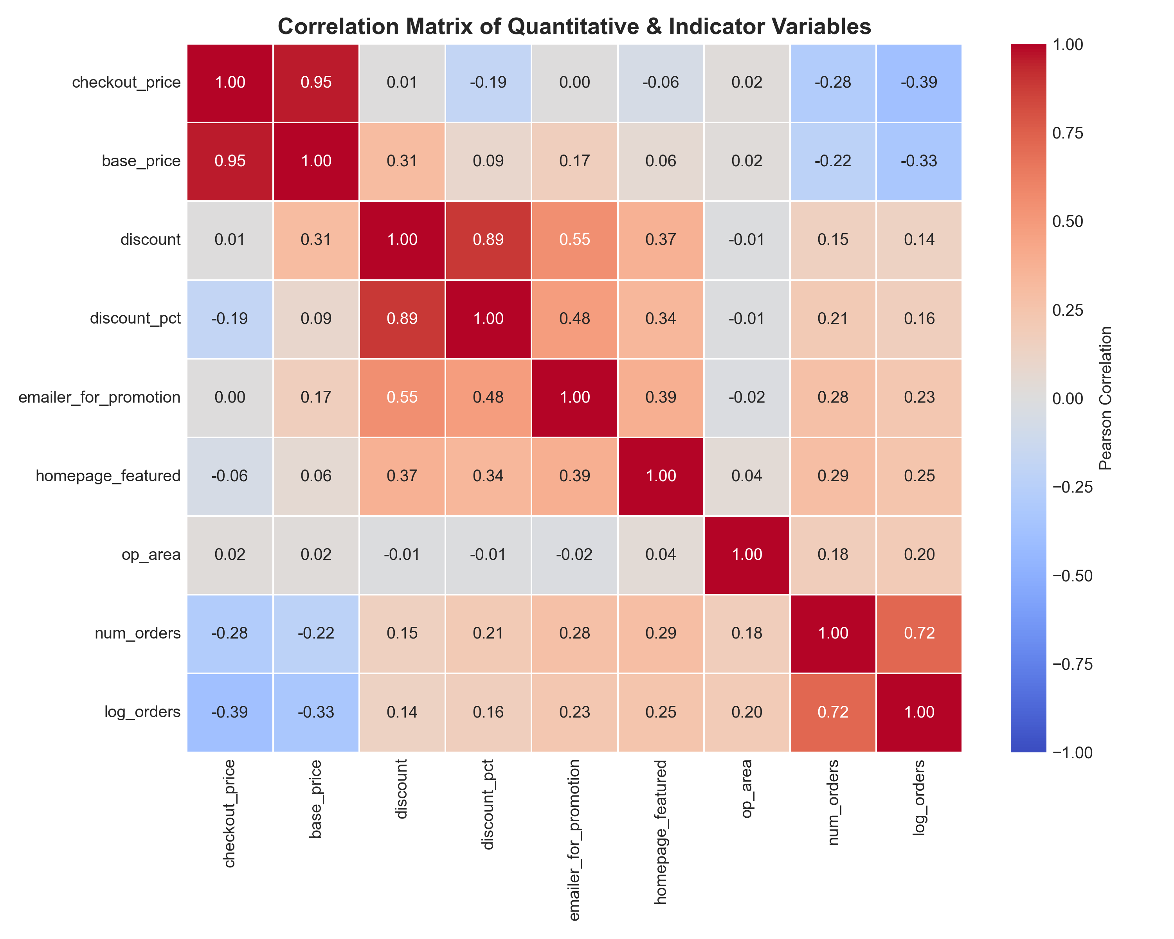
Figure 1.7: Pearson Correlation Matrix across Numerical Operational Features
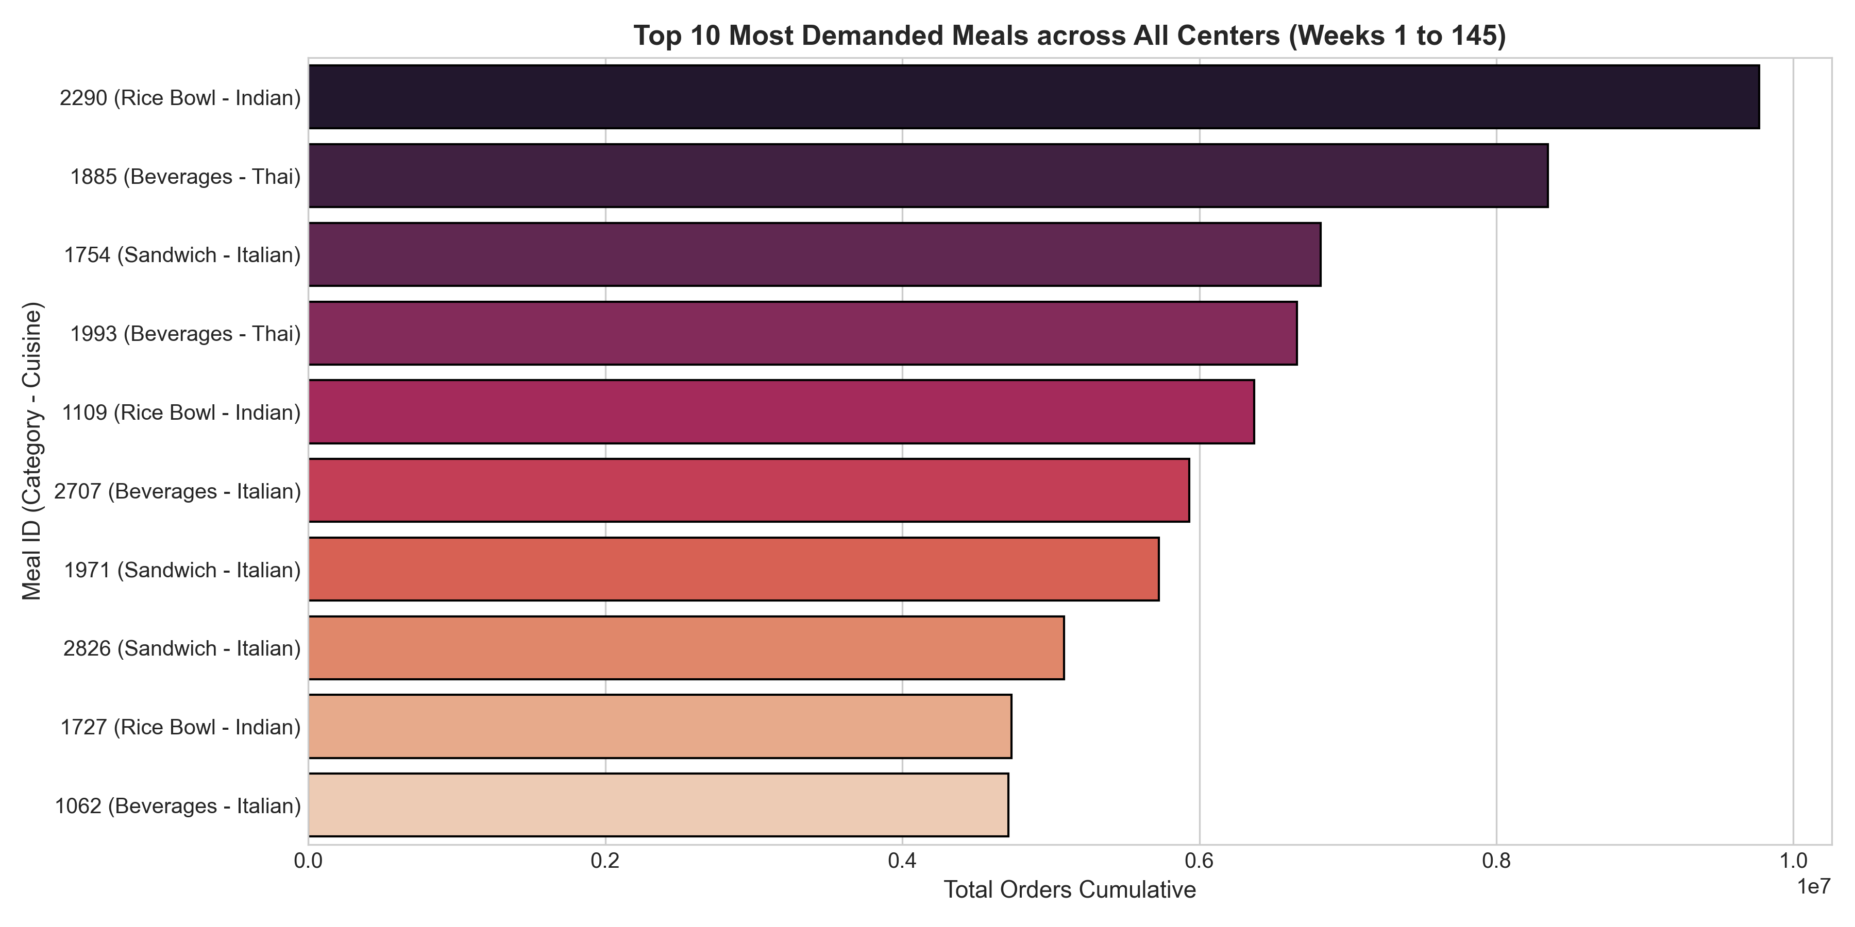
Figure 1.8: Top 10 High-Velocity Meal Items Ranked by Cumulative Order Volume

5.5 Limitations and Threats to Validity
Several potential threats to empirical validity must be noted:
- Censored Stock-out Demand: Point-of-sale logs record fulfilled orders rather than true customer demand. During severe kitchen stock-outs or app crashes, unfulfilled demand is censored, potentially biasing downward predictions for high-velocity items during extreme surges.
- Unobserved Environmental Confounders: The dataset does not record localized weather conditions (heavy monsoon rains, extreme heat), which strongly modulate consumer willingness to order delivery.
- Cold-Start SKU Limitations: For newly introduced meals with zero past ordering history, lag features are unavailable, requiring fallback to cuisine-level baseline priors.

Chapter 6: Conclusion and Future Work

6.1 Summary of the Research
This research formulated, implemented, and empirically validated an end-to-end dual-tier predictive analytics platform for large-scale kitchen logistics. By integrating non-linear gradient boosted regression (LightGBM) at the micro SKU-center level with multiplicative seasonal ARIMA (SARIMA) econometrics at the macro network level, the framework addresses the asymmetric operational challenges of food perishability, promo surge shocks, and courier capacity provisioning.

6.2 Major Findings
The key empirical findings of this investigation are:
- Superiority of Non-Linear Tree Boosting: LightGBM trained on log1p space achieved superior accuracy on unseen holdout Weeks 121–145 (MAE: 71.84, RMSE: 168.77, R²: 0.7873), outperforming traditional moving averages by over 30%.
- Dominance of Temporal Momentum: Lag-1 order volume and 4-week rolling means contributed 44.2% of directional split gain, confirming that recent customer purchasing momentum dominates long-term static priors.
- Quantifiable Marketing Impact: Promotional app spotlights and email blasts generate non-linear demand lifts exceeding +30.8%, which can be accurately anticipated through relative discount ratio modeling.
- Quarterly Seasonal Macro Stability: Network aggregate delivery demand contains pronounced 12-week quarterly periodicity. The SARIMA(0,1,2)(1,0,1)₄ specification achieved an out-of-sample MAPE of 9.64% with zero remaining residual autocorrelation.

6.3 Research Contributions
This study makes three primary contributions to predictive analytics and logistics engineering:
- 1. Dual-Tier Hierarchical Framework: Demonstrating how micro SKU predictions and macro fleet sizing can be unified into a single operational architecture.
- 2. Methodological Rigor in Food Demand Skewness: Proving that log1p target transforms combined with GOSS tree partitioning resolve severe positive skewness in point-of-sale data without numerical overflow.
- 3. Operational Decision Support System: Developing a fully interactive, verified web decision system (FoodPulse AI) that translates predictive machine learning inferences into physical ingredient kilogram prep orders and courier rider dispatch allocations.

6.4 Limitations
The current implementation is constrained by the weekly temporal granularity of the underlying point-of-sale data, which precludes intra-day hourly lunch vs. dinner dispatch scheduling. Furthermore, localized weather shocks and traffic congestion indices were not captured in the historical logs.

6.5 Future Research Directions
Future research directions to extend this work include:
- Deep Learning Attention Architectures: Benchmarking modern attention-based architectures, such as the Temporal Fusion Transformer (TFT), to evaluate multi-horizon quantile forecasting across the entire 77-center network.
- Spatial Network Modeling: Constructing spatial graph neural networks (GNN) to model courier route transfer and demand cannibalization between adjacent fulfillment centers.
- Real-time Meteorological Ingestion: Integrating live precipitation and temperature APIs to dynamically scale safety buffer stocks ahead of monsoon weather events.

REFERENCES / BIBLIOGRAPHY
[1] G. E. Box, G. M. Jenkins, G. C. Reinsel, and G. M. Ljung, Time Series Analysis: Forecasting and Control, 5th ed. Hoboken, NJ: John Wiley & Sons, 2015.
[2] A. C. Cameron and P. K. Trivedi, Regression Analysis of Count Data, 2nd ed. Cambridge: Cambridge University Press, 2013.
[3] T. Chen and C. Guestrin, 'XGBoost: A scalable tree boosting system,' in Proc. 22nd ACM SIGKDD Int. Conf. Knowl. Discovery Data Mining (KDD), 2016, pp. 785–794.
[4] J. H. Friedman, 'Greedy function approximation: A gradient boosting machine,' Annals of Statistics, vol. 29, no. 5, pp. 1189–1232, 2001.
[5] G. Ke, Q. Meng, T. Finley, T. Wang, W. Chen, W. Ma, Q. Ye, and T.-Y. Liu, 'LightGBM: A highly efficient gradient boosting decision tree,' in Advances in Neural Information Processing Systems (NeurIPS), vol. 30, 2017, pp. 3146–3154.
[6] S. Makridakis, E. Spiliotis, and V. Assimakopoulos, 'The M5 competition: Background, organization, and results,' International Journal of Forecasting, vol. 38, no. 4, pp. 1325–1347, 2022.
[7] F. Pedregosa, G. Varoquaux, A. Gramfort, V. Michel, B. Thirion, O. Grisel, et al., 'Scikit-learn: Machine learning in Python,' Journal of Machine Learning Research, vol. 12, pp. 2825–2830, 2011.
[8] J. W. Taylor, 'Short-term demand forecasting using exponentially weighted methods,' Journal of the Operational Research Society, vol. 58, no. 7, pp. 915–924, 2007.
[9] S. Seabold and J. Perktold, 'Statsmodels: Econometric and statistical modeling with Python,' in Proc. 9th Python in Science Conf. (SciPy), 2010, pp. 92–96.
[10] B. Lim, S. O. Arik, N. Loeff, and T. Pfister, 'Temporal Fusion Transformers for interpretable multi-horizon time series forecasting,' International Journal of Forecasting, vol. 37, no. 4, pp. 1748–1764, 2021.
[11] R. J. Hyndman and G. Athanasopoulos, Forecasting: Principles and Practice, 3rd ed. Melbourne, Australia: OTexts, 2021.
[12] A. E. Hoerl and R. W. Kennard, 'Ridge regression: Biased estimation for nonorthogonal problems,' Technometrics, vol. 12, no. 1, pp. 55–67, 1970.
[13] R. J. Hyndman and A. B. Koehler, 'Another look at measures of forecast accuracy,' International Journal of Forecasting, vol. 22, no. 4, pp. 679–688, 2006.
[14] D. A. Dickey and W. A. Fuller, 'Distribution of the estimators for autoregressive time series with a unit root,' Journal of the American Statistical Association, vol. 74, no. 366, pp. 427–431, 1979.
[15] G. M. Ljung and G. E. Box, 'On a measure of lack of fit in time series models,' Biometrika, vol. 65, no. 2, pp. 297–303, 1978.

APPENDICES
Appendix A: Code and Dataset Availability
All source code, data preprocessing pipelines, exploratory analysis notebooks, serialized model artifacts, and interactive dashboard code developed in this research project are version-controlled and publicly accessible:
- Primary Git Repository: https://github.com/ijk037/sem5 (Branch: main)
- Exploratory Data Analysis Notebook: pa - food project/01_exploratory_data_analysis.ipynb
- Predictive Modeling Pipeline Notebook: pa - food project/02_predictive_modeling.ipynb
- Time Series Forecasting Notebook: pa - food project/03_time_series_forecasting.ipynb
- Production Model Pipeline Artifact: pa - food project/models/best_demand_lgbm.joblib
- Macro SARIMA Pipeline Artifact: pa - food project/models/best_macro_sarima.joblib
- Interactive Dashboard Entrypoint: pa - food project/stitch_food_delivery_demand_analytics_dashboard/index.html
Appendix B: Relational Data Dictionary
The operational data schema is structured across three primary tables with foreign key linkages (center_id and meal_id):
- train.csv Schema: id (int64, PK), week (int64, 1–145), center_id (int64, FK), meal_id (int64, FK), checkout_price (float64, INR), base_price (float64, INR), emailer_for_promotion (int64, {0,1}), homepage_featured (int64, {0,1}), num_orders (int64, Target demand).
- fulfilment_center_info.csv Schema: center_id (int64, PK), city_code (int64), region_code (int64), center_type (object, {TYPE_A, TYPE_B, TYPE_C}), op_area (float64, 0.9–7.0 km²).
- meal_info.csv Schema: meal_id (int64, PK), category (object, 14 categories), cuisine (object, {Indian, Continental, Italian, Thai}).

